**DOCUMENT**

OFFICE STAFF RECORDS

**Submitted by**

Arya N R

**Under the guidance of**

Poovaragavn Velumani

**ABSTRACT**

This study improved on the existing system in which staff records are being managed and maintained in the record section of the office. The need to have a office system of record management is necessary, and this led to the development of office staff record management system using K-Way Merge Sort Algorithm for sorting and merging of the data in the database to produce the required information in a requested format, which before normally waste time, with a lot of inadequacy in the report.

**INTRODUCTION**

OBJECTIVE

The main objective of the Office Staff Records Management System is to manage the details of staffs Attendances, task, Recourses, Time entries. The purpose the project is to build an application program to reduce the manual work for managing the staffs details.

INTRIDUCTION

The system was designed by creating a relational database with MYSQL to accept staffs record effectively and, designing a web-based solution using PHP, JavaScript and HTML at the front-end. The MYSQL was placed at the back-end of the database in order to be able to give the record section of a more secured and effective office staffs record management system. The developed system introduced k-way merge sort algorithm to query the database in order to generate required report, sorting and collating of different related fields as enquired, merging them to form a single output, and keeping the updated records in the archive for future references.

PROJECT DESCRIPTION

This study improved on the existing system in which staff records are being managed and maintained in the record section of the office. The system was designed by creating a relational database with MYSQL to accept staffs record effectively and, designing a web-based solution using PHP, JavaScript and HTML at the front-end. The MYSQL was placed at the back-end of the database in order to be able to give the record section of a more secured and effective office staffs record management system.

SCOPE

The purpose of the Office Staff record systems program is to provide a mechanism that handles the office operations using a computer within a function of a second. The app preserves all relevant data like a manual file-keeping method in a database, this integrated framework is user friendly and error free. Using this automatic method, paperwork and manual power can be minimized.

FEASIBILITY OF STUDY

A feasibility of study is a high level capsule version of the entire system analysis and design process. The study begins by classifying the problem definition. Feasibility is to determine if it

Is worth doing. Once an acceptance problem definition has been generated, the analyst develops a logical model of the system. A search of a alternatives is analyzed carefully.

SOFTWARE DEVELOPMENT ENVIRONMENT

Web Development using PHP and MySQL. PHP (or PHP Hypertext Preprocessor) is a server-side scripting language that is used to create dynamic web pages that can interact with databases. It is a widely-used open source language that is specifically used for web application development and can be embedded within HTML. MySQL is a freely available open source Relational Database Management System (RDBMS) that uses Structured Query Language (SQL). SQL is the most popular language for adding, accessing and managing content in a database. It is most noted for its quick processing, proven reliability, ease and flexibility of use.

**SYSTEM DESIGN**

ER DIAGRAM

An Entity-Relationship Model (ER Model) describes the structure of a database with the help of a diagram, which is known as Entity Relationship Diagram (ER Diagram). An ER Model is a design or blueprint of a database that can later be implemented as a database.

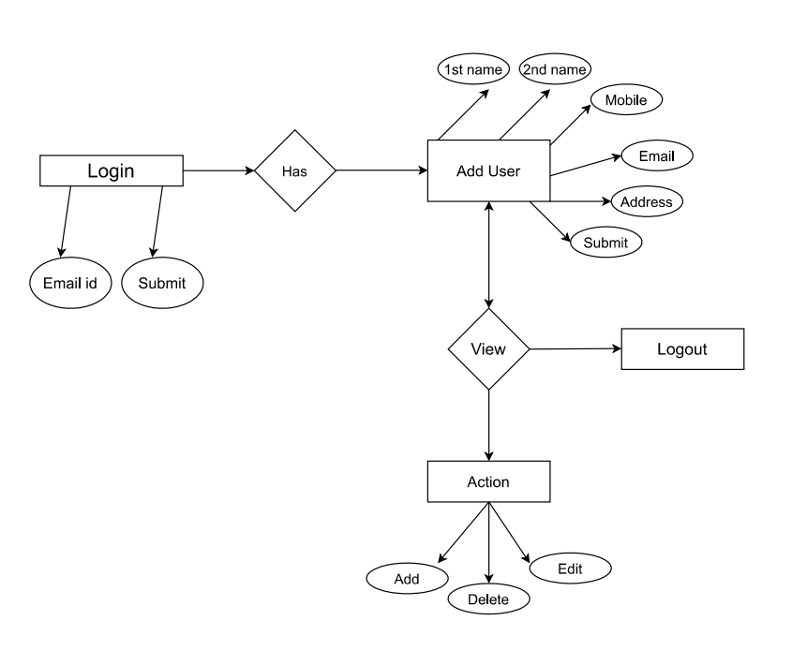

CLASS DIAGRAM

The class diagram shows a set of classes, interface, collaborations and their relationships.

Add New User

1st name

2nd name

Email id

Mobile No

Address

Submit

View

Name

Mobile

Email

Created date

Logout

Login

Email

Submit

Action

Edit

Delete

View

FLOW CHART

A Flowchart is a type of diagram that represents a workflow or process. A flowchart can also defined as a diagrammatic representation of an algorithm, a step by step approach to solving a task.

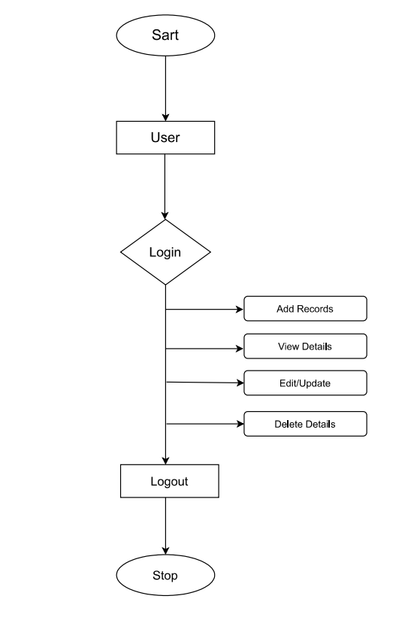

**SYSTEM REQUIREMENTS**

SOFTWARE REQUIREMENTS

Operating System :Windows 7, Windows 10

Front End :Html, CSS, JavaScript

Back End :PHP, MySQL

Code Editor :Visual Studio Code

Software :Xampp Server

Browser :Google Chrome

HARDWARE REQUIREMENTS

Processor :Intel Core i3

Ram size :4.00GB

Network Connectivity :LAN or Wi-Fi

Hard Disk Capacity : 1Tb